# Book Management Application

I - Requirement

Write a complete, well-structured program that begins by asking the user to enter bibliographic information of library items, such as books, CDs, photographs. The program will produce a database with the input values and display the stored ones to users.

II – General Architecture

0. Application Functionalities.

From requirements, the application will have 4 main functionalities:

- List all of books in the system

- Insert new book

- Delete existing book

- Search book

1. Data Structure

In order to store Book information, we need to design a structure for Book first. It should keep some important information of a book such as: Identification Number, Title, Author, Year. Books inserted will be stored in a global array.

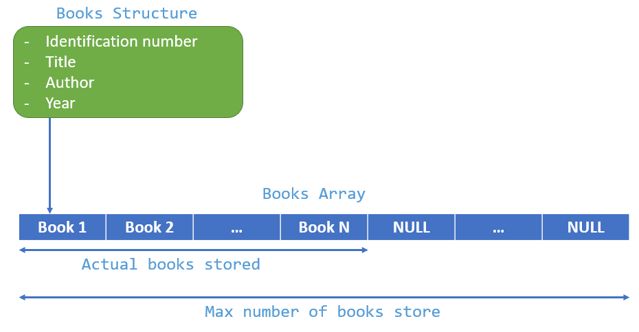

Implementation:

Max number of books store

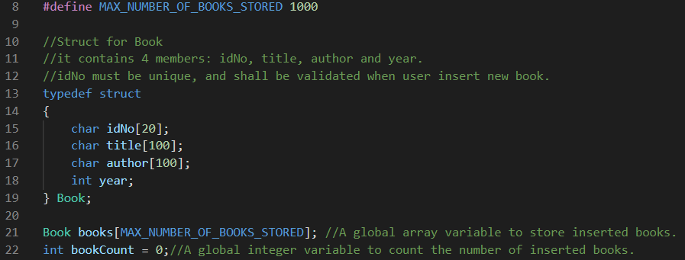

2. Application structure

As application functionalities, the application will have 5 corresponding screens:  
-Main screen.

-List of Books screen

-Insert Book screen

-Delete Book screen

-Search Book screen

On each screen has its own functionalities, and can navigate to another screen from a specific screen.

Generally, each screen also has same points in operation. They show screen title, content with their functionality, and option menu.

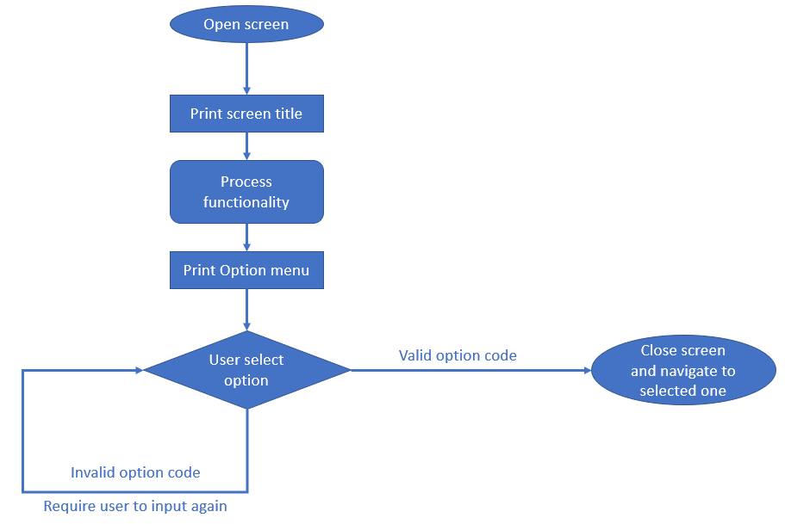

Printing option menu and letting user select option should be done in a common function, and can be used by all screens. In term of programming, I intend to make an infinity loop to deal with re-inputting option code when user keyed-in an invalid one before.

Block Diagram:

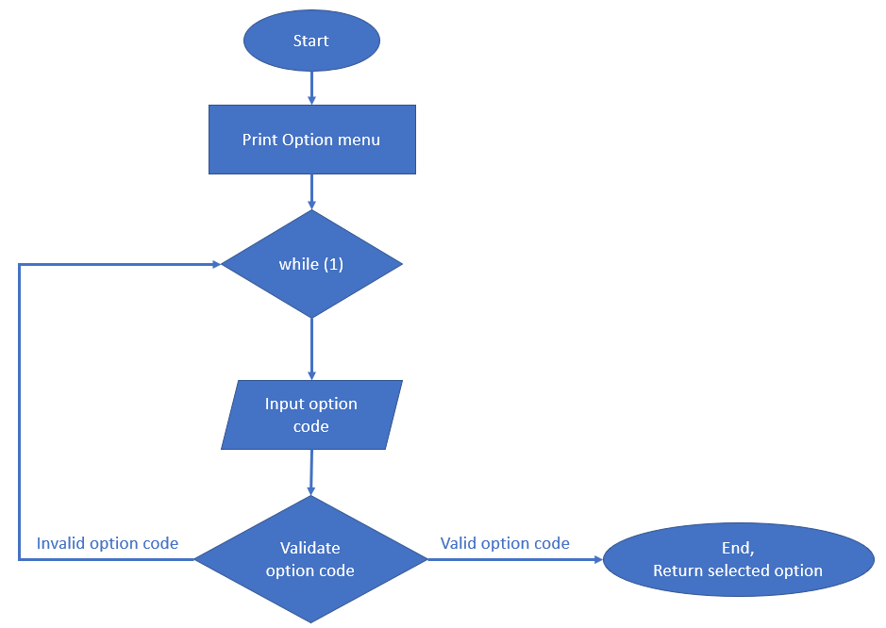

Implementation:

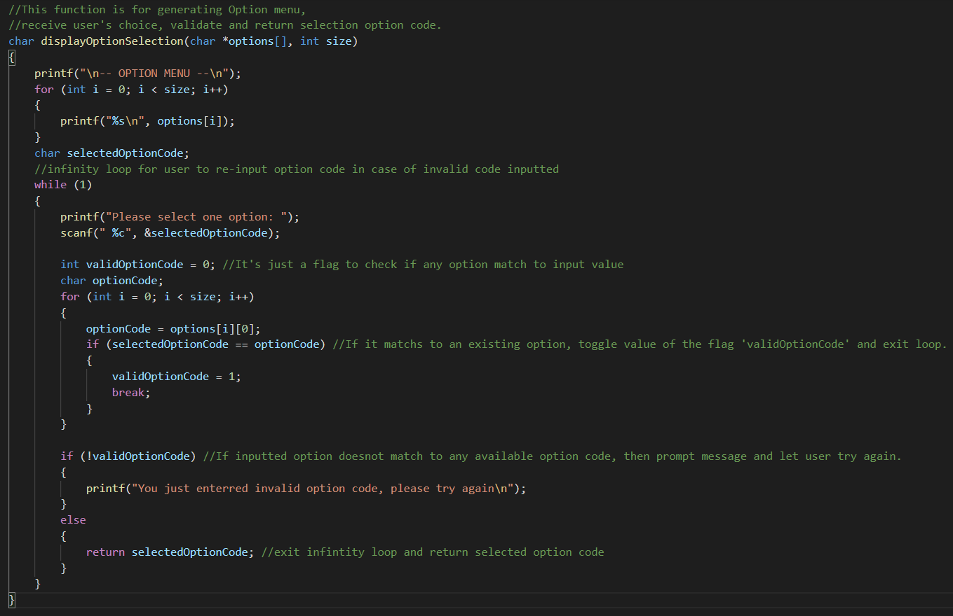

2.1 Main screen

First of all, once use run the application, the main screen will be shown to user. If no book was added yet, the screen will notice user to insert book first.

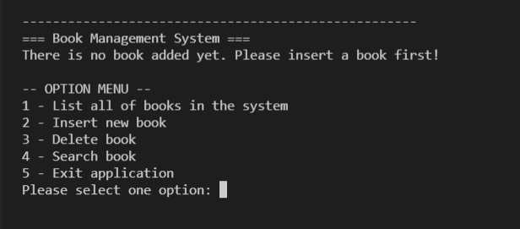

There are 5 options for Main screen:

- List all of books in the system

- Insert new book

- Delete book

- Search book

- Exit application

Except of the last option, user will be navigated to the particular screen after he selects.

Block Diagram:

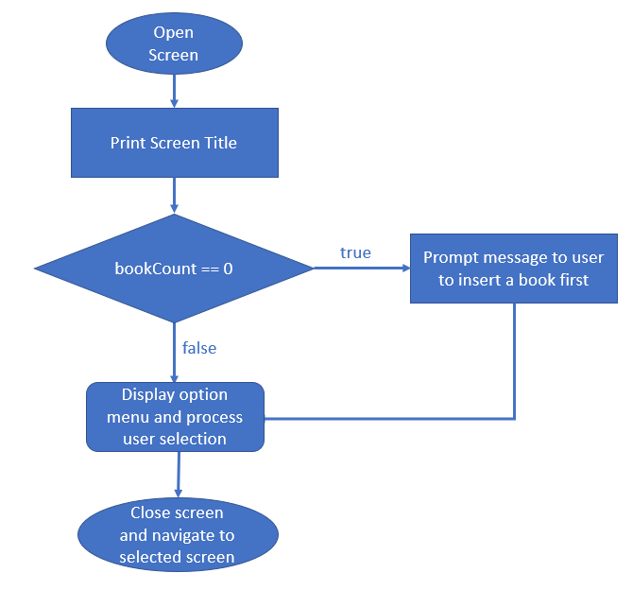

Implementation:

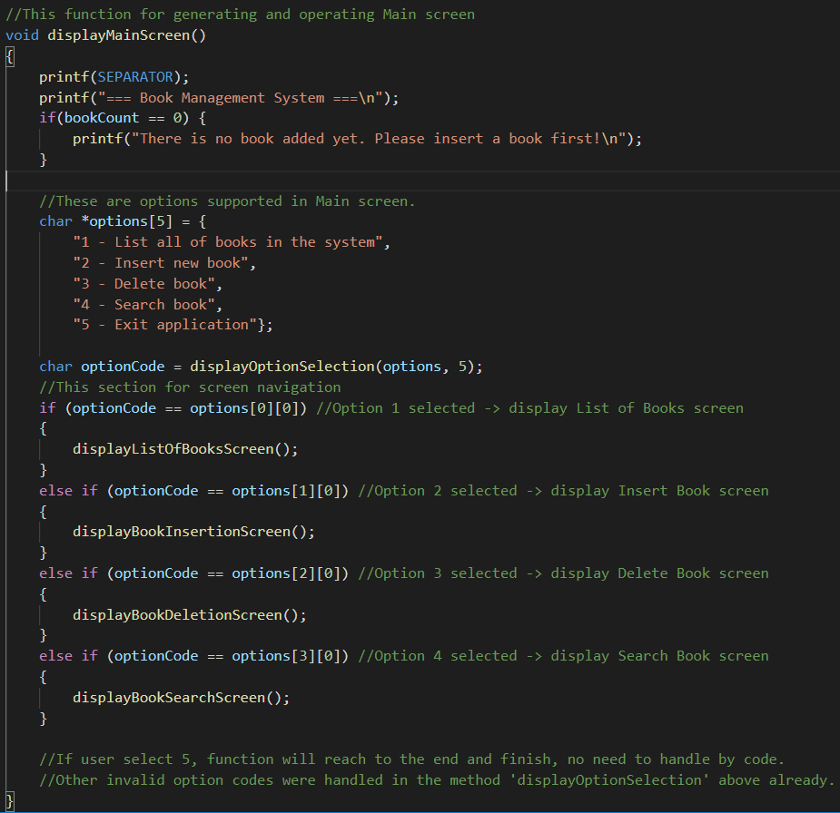

2.2- List of Books screen

This screen will list all of books stored in the system. In case of no book added yet, it prompts a message to user to insert a book first.

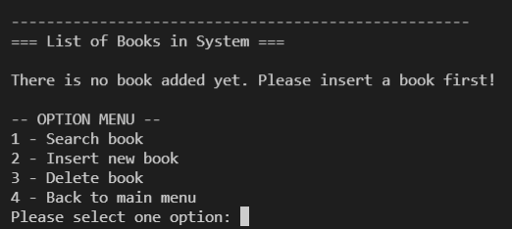

Otherwise, it will show all books with details stored in the system.

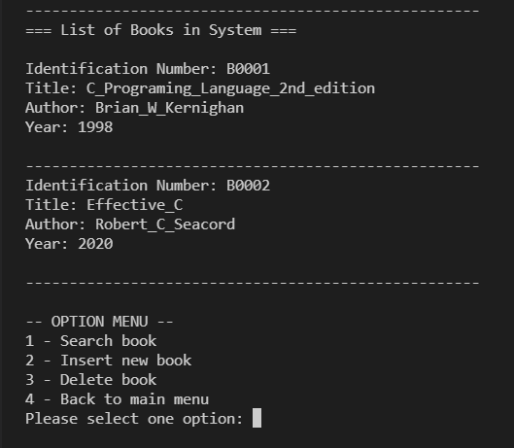

This screen has 4 available options:

1 - Search book

2 - Insert new book

3 - Delete book

4 - Back to main menu

Block diagram

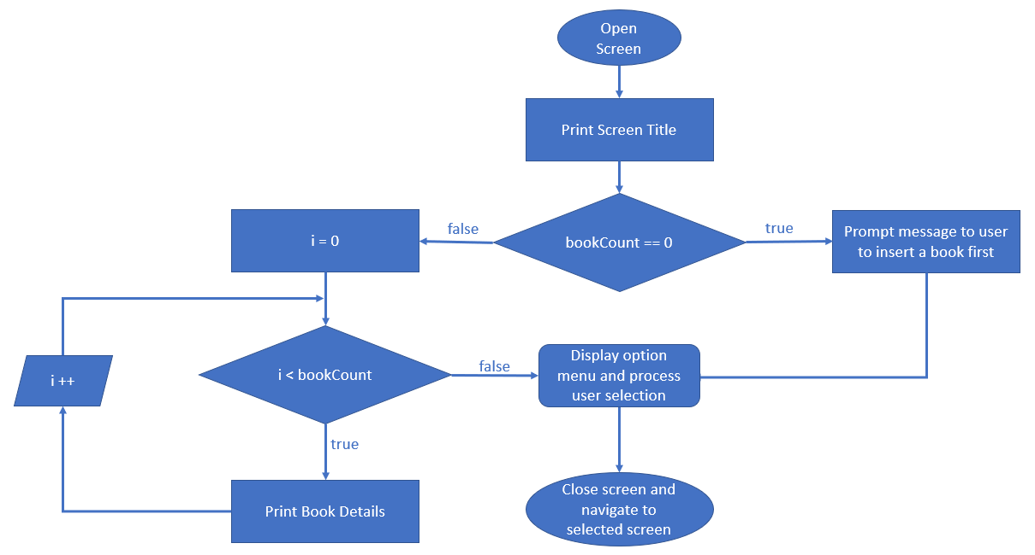

Implementation